**CLASS IX COMPUTER PAPER**

**Q.NO1 a. CHOOSE THE RIGHT ANSWER**

1.THE DEVICE THAT CONVERTS HARD COPY INTO SOFT COPY IS :

A) PRINTER B) PLOTTER C) SCANNER D) BARCODE READER 2. THE VOLATILE MEMORY

A) IS PARMANENT B) LOSES CONTENTS AS THE POWER IS DISCONNECT

C) POSSESSES LARGE STORAGE D) MANAGES HARDWARE RESOURCES 3. MEDIA PLAYERS ARE :

A) BUSINESSS SOFTWARE B) EDUCATION SOFTWARE

C) ENTERTAINMENT SOFTWARE D) PRODUCTIVITY SOFTWARE

4.THE PROGRAMTHAT ARE GENERALLY INSTALLED TO MANAGE AND MAINTAIN

OVERALL COMPUTER RESOURCES IS:

A) OPERATING SYSTEM B) UTILITY PROGRAM C) LANGUAGE TRANSLATOR D) DEVICE DRIVER

5. MODERN LANGUAGES USE

A) COMPILER B) INTERPRETER C) CONVERTOR D) ASSEMBLER

6. A COLLECTION OF WIRES CONNECTING THE CPU WITH MAIN MEMORY THAT IS USED TO

IDENTIFY PARTICULAR LOCATION IS:

A)CONTROL BUS B) DATA BUS C) ADDRESS BUS D) MEMORY BUS

7. THE INEXPENSIVE AND MOST COMMONLY USED COMPUTERS Are,

a) super computer b)mainframe computer c)minicomputer d)microcomputer

8) computer cannot start without:

a)operating system b)utility program c)device drivers d)business software

9)graphical user interface (GUI) was developed in:

a)second generation b)fourth generation c)mechanical era d)electro-mechanical era

10)a person who uses different programming languages to develop programs is:

a)data base administrator b) web designer c)software engineer d) graphic designer

**QNO.1b**

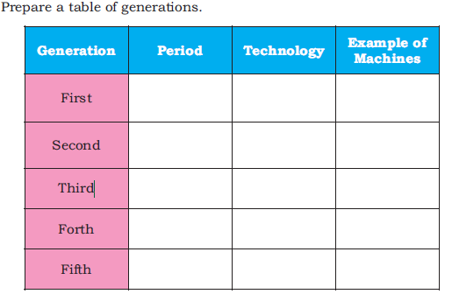

**Q.NO 1 c** . Match the column

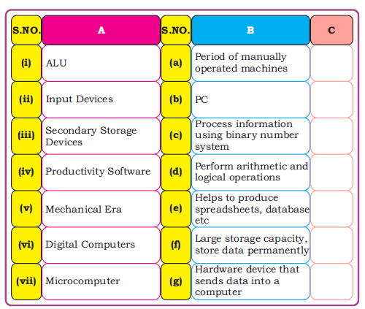

2.Define the ABACUS and Napier bone? 3.Explain the any three generations of computer? 4.Discuss types of computer according to size ? 5. Discuss types of computer according to technology? 6.What is translator and its types?

7.What is buses .Discuss its types.